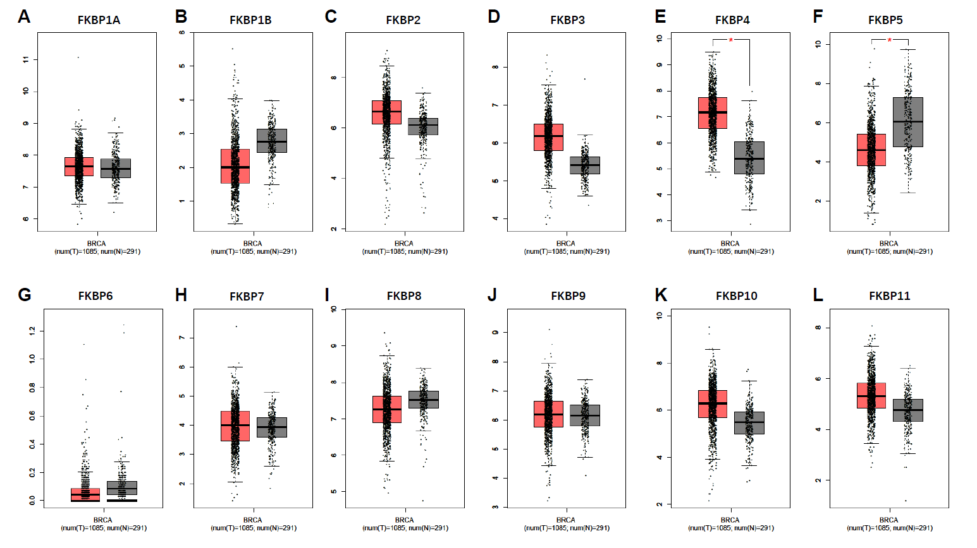
FigureS1. Differential expressions of twelve FKBP family genes on the GEPIA database. (A-D, G-L) The expression levels of 10 FKBPs have no significant change between tumor group (T) and normal group (N); (E, F) The expression levels of FKBP4 and FKBP5 have significant changes between tumor group (T) and normal group (N), *P<0.05.

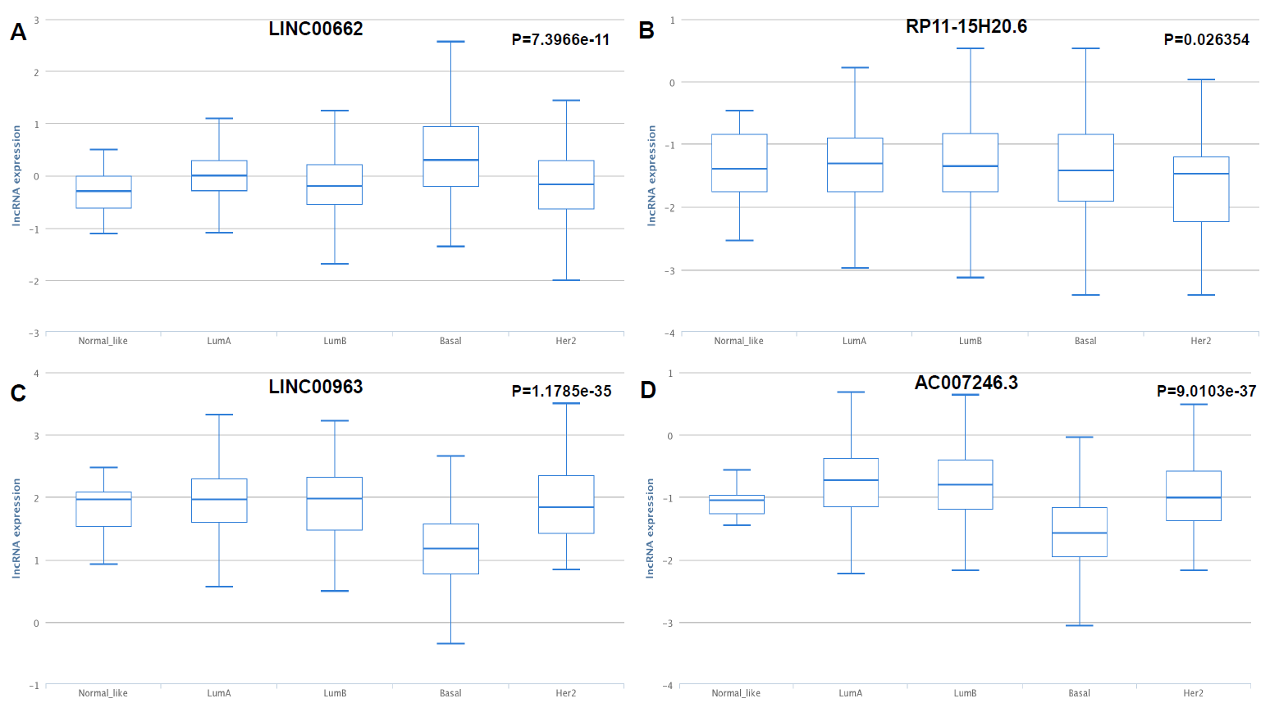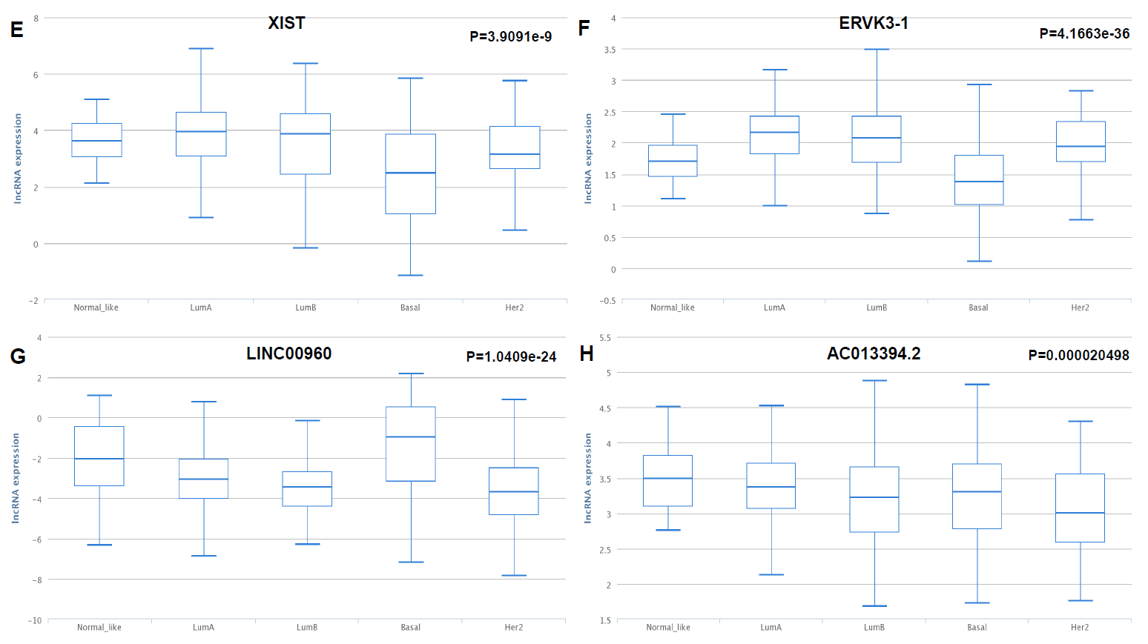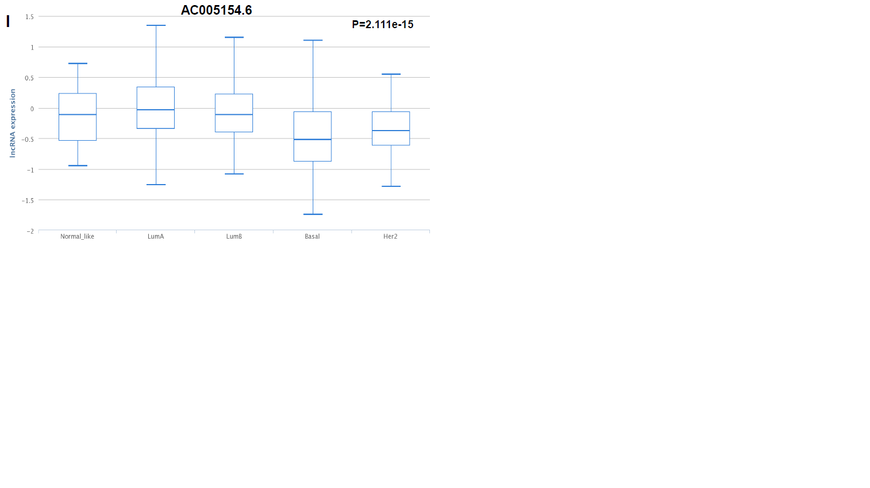
FigureS2. LncRNAs expression analysis in four subtypes of BC (TANRIC database). (A-F) Six significantly upregulated lncRNAs in BC tissues; (G-I) Three significantly downregulated lncRNAs in BC tissues.
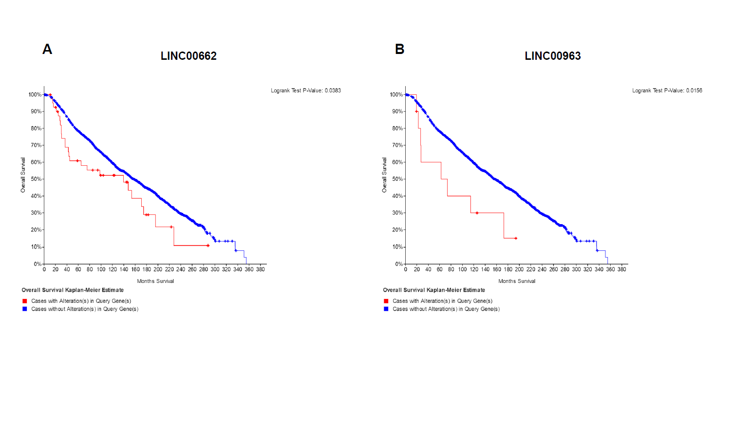
FigureS3. Survival curves in BC patients are plotted correlated with (A) LINC00662 and (B) LINC00963.
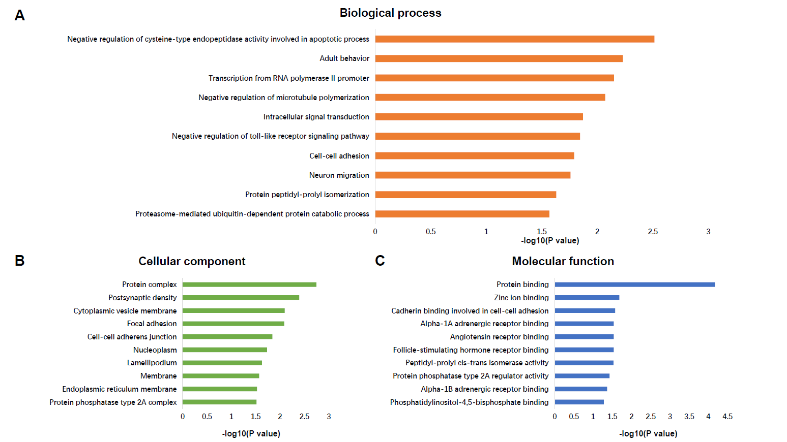
FigureS4. GO analysis of candidate genes. (A) The top ten enriched BP items of predicted genes; (B) The top ten enriched CC items of predicted genes; (C) The top ten enriched MF items of predicted genes.
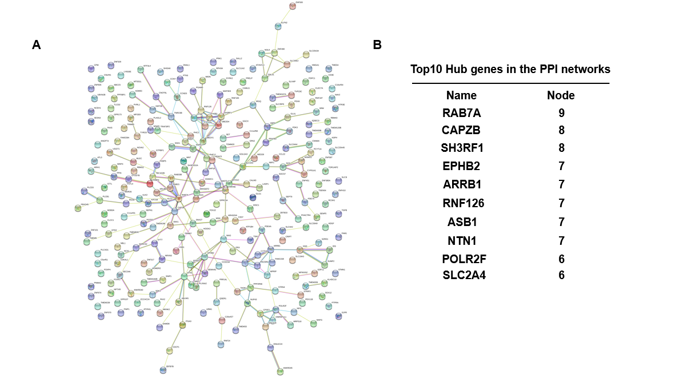
FigureS5. Protein to protein Interactions among candidate genes and screening of hub genes. (A) PPI networks of targeted genes of DE-miRNAs; (B) Screened hub genes of the PPI networks.
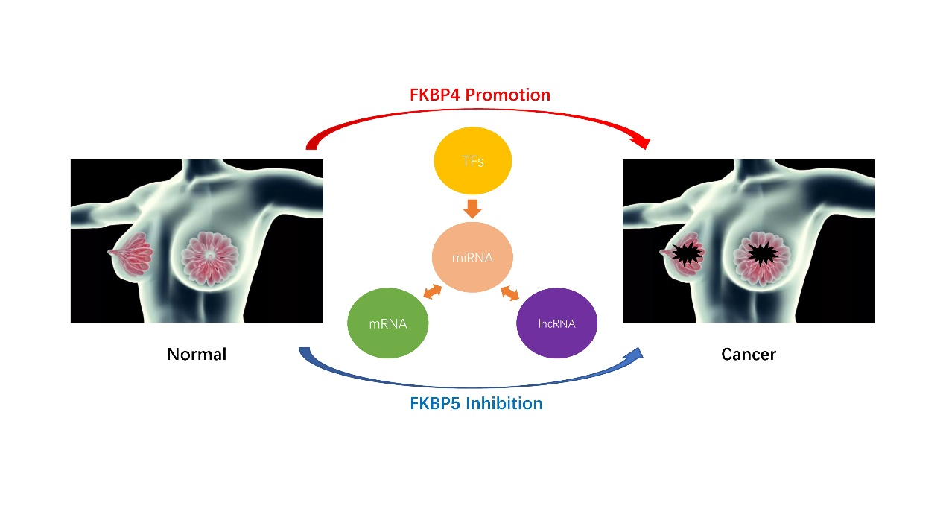
FigureS6. The predicted TFs-miRNA-lncRNA/mRNA regulatory network of FKBP4 and FKBP5 in BC. FKBP4 promotes breast cancer and FKBP5 inhibits breast cancer via multiple key TFs-miRNA-lncRNA/mRNA interactions.

